Flower Power Forum Page With User Authentication

Casey Phung

Rajwinder Kaur

Duncan Mac

Steven Castaneda

Prof. Zamora

CISW 31 & 31L

12/12/2018

* Group Members

***Hao Phung*** - Lead Programmer

***Rajwinder Kaur*** - Front End Developer and Graphic Designer

***Steven Castaneda*** - Server Admin and Tester/Quality Assurance

**Duncan Mac** - Content Developer/Quality Assurance

* Introduction

We chose the template for a forum page which was bare and minimalistic and wanted to do more and add more functionalities. Along with new logos and a new design to make it more user friendly, we added user authentication and fully implemented it onto our forum. Now you are able to create a user and save your username and password onto a fully functioning database. This database saves your information and you are then able to go onto our login page and login to access our forum page. Our forum page also has an easy to use toolbar which allows you to collapse and expand all forums and replies, and also a button to create a new post. Creating a new post is also very user friendly, with just simple text boxes with clear labels that anyone can use. The purpose of our group was to make this project as user friendly as possible and we were able to achieve that by using the old template, adding and modifying its design, and adding new features that make it accessible to all users. We created this project using a partition of Fedora 28 and the use of LAMP.

* Database

We used mariadb for our needs of mysql in Fedora 28. We created Three tables, A table names ‘Body’ which holds all the content in every post, every new post and every reply is held by this tables. The next table we created was ‘Header’ which holds a field for ‘parent’ which indicates if its a main post or a reply post, ‘poster’ which holds the names of the poster, ‘title’ which holds the title of the given post, ‘children’ which holds the number of replies the post has, ‘posted’ which shows the time a given post was posted, and ‘postid’ which shows the position the given post is in the tree. The last table ‘user’ holds user information in the fields ‘username, which holds username data, ‘passwd’ which saves password data in a hash format and ‘email’ which holds your email data. These three tables are the main tables we used to hold and save user and content data for our forum.

Database and Tables: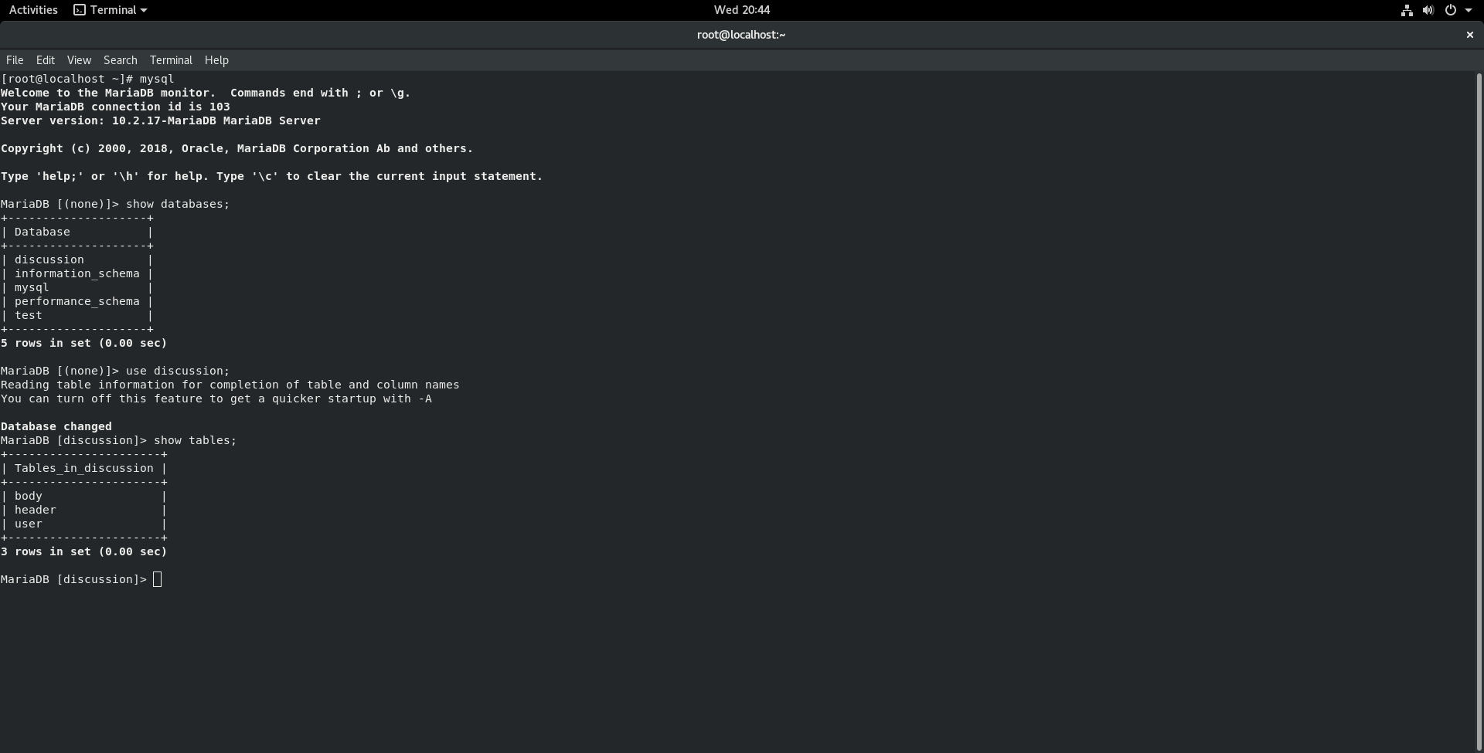

Body: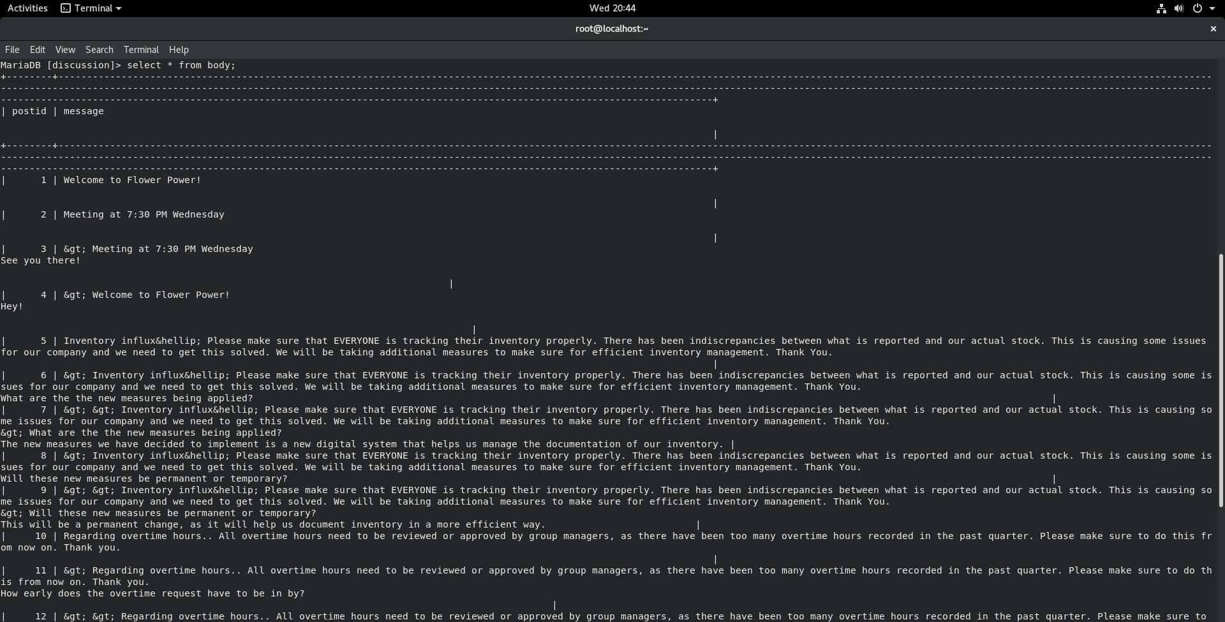

Header: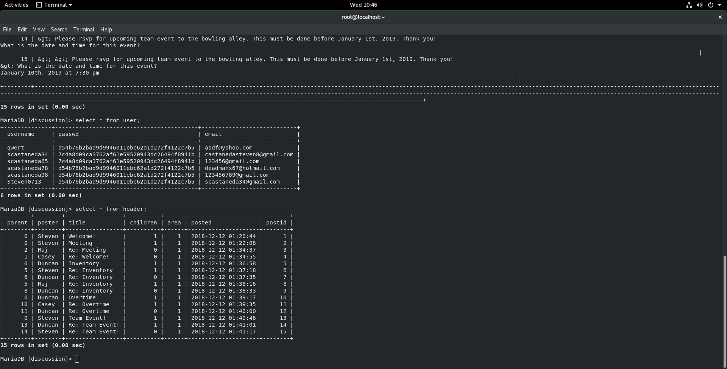

User: